Linux is an open-source UNIX-based operating system. The main component of the Linux operating system is Linux kernel. It is developed to provide low-cost or free operating system service to personal system users, which includes an X-window system, Emacs editor, IP/TCP GUI, etc.

Linux distribution:
Linux distribution is developed using a set of software based on compatibility with the Linux core kernel, using which Linux-based operations in different systems, such as personal systems, embedded systems, etc. There are around 600 distributions available.
Some Linux distributions are: MX Linux, Manjaro, Linux Mint, elementary, Ubuntu, Debian, Solus, Fedora, openSUSE, Deepin

Components of Linux:
Like any operating system, Linux consists of software, computer programs, documentation, and hardware.
The main components of Linux operating system are: Application, Shell, Kernel, Hardware, Utilities
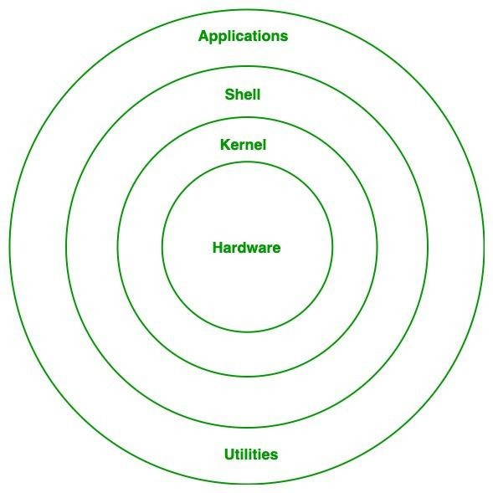
Linux operating system architecture

1. Kernel:
Kernel is the main core component if Linux, it controls the activity of other hardware components. It visualizes the common hardware resources and provide each process with necessary virtual resources. It makes the process to wait in the ready queue and execute in consequently to avoid any kind of conflict.
Different of types of kernel:
1.1. Monolithic Kernel:
Monolithic kernel is a type of operating system kernel, where all the concurrent processes are executed simultaneously in the kernel itself. All the processes share same memory recourses.
1.2. Micro kernel:
In micro kernel user services and kernel services are executed in separate address spaces. User services are kept in user address space and kernel services are kept in kernel address space.
1.3. Exokernel:
Exo-kernel is designed to manage hardware resources at application level. High level abstraction is used in this operating system to offer hardware resources access to kernel.

1.4. Hybrid kernel:
It is the combination of both monolithic kernel and microkernel. It has speed and design of monolithic kernel and modularity and stability of microkernel.

Main Subsystems of kernel:
- Process scheduler: Responsible for fairly distributing the the processing time among all the concurrently running process.
- Memory management unit: This kernel sub unit is responsible for proper distribution of memory resources among the concurrently running process.
- Virtual file system: This subsystem provides interface to access stored data across different file system and different physical media
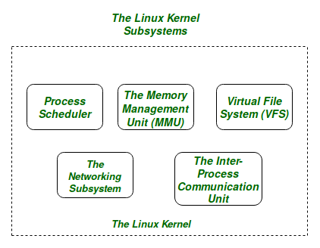
Kernel subsystems

2. System Library:
System libraries are some predefined functions by using which any application programs or system utilities can access kernel’s features. These libraries are the foundation upon which any software can be built.
Some of the most common system libraries are:
- GNU C library: This is the C library that provides the most fundamental system for the interface and execution of C programs. This provides may in-built functions for the execution.
- libpthread (POSIX Threads): This library plays important role for multithreading in Linux, it allows users for creating and managing multiple threads.
- libdl (Dynamic Linker): This library is responsible for the loading and linking file at the runtime.
- libm (Math Library): This library provides user with all kind of mathematical function and their execution.
Some other system libraries are: librt (Realtime Library), libcrypt (Cryptographic Library), libnss (Name Service Switch Library), libstdc++ (C++ Standard Library)

3. Shell:
Shell can be determined as the interface to the kernel, which hides the internal execution of functions of kernel from the user. Users can just enter the commend and using the kernel’s function that specific task is performed accordingly.
Different types of shell:
3.1. Command Line shell:
Executes the command provided by user given in the form command. A special program called terminal in executed and the result is displayed in the terminal itself.

3.2. Graphical User Interface:
Executes the process provided by user in graphical way and output is displayed in the graphical window.
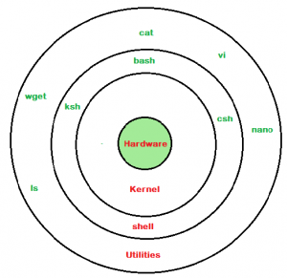
Linux shell

4. Hardware Layer:
Hardware layer of Linux is the lowest level of operating system track. It is plays a vital role in managing all the hardware components. It includes device drivers, kernel functions, memory management, CPU control, and I/O operations. This layer generalizes hard complexity, by providing an interface for software by assuring proper functionality of all the components.

5. System utility:
System utilities are the commend line tools that preforms various tasks provided by user to make system management and administration better. These utilities enables user to perform different tasks, such as file management, system monitoring, network configuration, user management etc.

Conclusion:
The most powerful and versatile component of Linux operating system is Kernel, using which functional of whole operating system can be controlled. Kernel provides a huge range of functionality, which can be easily accessed by the user in an interactive way using shell. For the proper functionality of the operating system, proper hardware are needed. All the components of the the operating system make it easier, faster, stable and reliable.
Unlock the Power of Placement Preparation!
Feeling lost in OS, DBMS, CN, SQL, and DSA chaos? Our Complete Interview Preparation Course is the ultimate guide to conquer placements. Trusted by over 100,000+ geeks, this course is your roadmap to interview triumph.
Ready to dive in? Explore our Free Demo Content and join our Complete Interview Preparation course.

Open-Source Operating System
In this article, you will learn about the open-source operating system with its working advantages, disadvantages and some best open-source operating system.

What is an Open-Source Operating System?
The term "open source" refers to computer software or applications where the owners or copyright holders enable the users or third parties to use, see, and edit the product's source code. The source code of an open-source OS is publicly visible and editable. The usually operating systems such as Apple's iOS, Microsoft's Windows, and Apple's Mac OS are closed operating systems. Open-Source Software is licensed in such a way that it is permissible to produce as many copies as you want and to use them wherever you like. It generally uses fewer resources than its commercial counterpart because it lacks any code for licensing, promoting other products, authentication, attaching advertisements, etc.
The open-source operating system allows the use of code that is freely distributed and available to anyone and for commercial purposes. Being an open-source application or program, the program source code of an open-source OS is available. The user may modify or change those codes and develop new applications according to the user requirement. Some basic examples of the open-source operating systems are Linux, Open Solaris, Free RTOS, Open BDS, Free BSD, Minix, etc.
In 1997, the first Open-Source software was released. Despite the industry, there are now Open-Source alternatives for every Software program. Thanks to technological developments and innovations, many Open-Source Operating Systems have been developed since the dawn of the 21st century.

Different Shells in Linux
• Read
• Discuss
• Courses

SHELL is a program which provides the interface between the user and an operating system. When the user logs in OS starts a shell for user. Kernel controls all essential computer operations, and provides the restriction to hardware access, coordinates all executing utilities, and manages Resources between process. Using kernel only user can access utilities provided by operating system.
Types of Shell:
- The C Shell –
Denoted as csh
- Bill Joy created it at the University of California at Berkeley. It incorporated features such as aliases and command history. It includes helpful programming features like built-in arithmetic and C-like expression syntax. In C shell:
Command full-path name is /bin/csh,
Non-root user default prompt is hostname %,
Root user default prompt is hostname #.
- The Bourne Shell –
Denoted as sh
- It was written by Steve Bourne at AT&T Bell Labs. It is the original UNIX shell. It is faster and more preferred. It lacks features for interactive use like the ability to recall previous commands. It also lacks built-in arithmetic and logical expression handling. It is default shell for Solaris OS. For the Bourne shell the:
Command full-path name is /bin/sh and /sbin/sh,
Non-root user default prompt is $,
Root user default prompt is #.
- The Korn Shell
It is denoted as ksh
- It was written by David Korn at AT&T Bell Labs. It is a superset of the Bourne shell. So it supports everything in the Bourne shell.It has interactive features. It includes features like built-in arithmetic and C-like arrays, functions, and string-manipulation facilities. It is faster than C shell. It is compatible with script written for C shell. For the Korn shell the:
Command full-path name is /bin/ksh,
Non-root user default prompt is $,
Root user default prompt is #.
- GNU Bourne-Again Shell –
Denoted as bash
- It is compatible to the Bourne shell. It includes features from Korn and Bourne shell. For the GNU Bourne-Again shell the:
Command full-path name is /bin/bash,
Default prompt for a non-root user is bash-g.gg$
(g.ggindicates the shell version number like bash-3.50$),
Root user default prompt is bash-g.gg#.
- T Shell –
Denoted as tsh
- It was originally developed for the Plan 9 operating system, but has since been ported to other systems, including Linux, FreeBSD, and macOS.
Command full-path name is /bin/tcsh,
Default prompt for a non-root user is abhishekaslk(user):~>
Root user default prompt is root@abhishekaslk(user):~#.
- Z Shell –
Denoted by zsh
- Z Shell (zsh) was created by Paul Falstad in 1990 while he was a student at Princeton University. Z Shell is an extended version of the Bourne-Again Shell (bash), with additional features and capabilities.
Command full-path name is /bin/zsh,
Default prompt for a non-root user is abhishekaslk(user)%
Root user default prompt is root@abhishekaslk(user):~#
Whether you're preparing for your first job interview or aiming to upskill in this ever-evolving tech landscape, GeeksforGeeks Courses are your key to success. We provide top-quality content at affordable prices, all geared towards accelerating your growth in a time-bound manner. Join the millions we've already empowered, and we're here to do the same for you. Don't miss out - check it out now!

Last Updated : 03 May, 2023
14
Previous
How to Create a Shell Script in linux
Next
Basic Shell Commands in Linux
Similar Reads

List out all the Shells Using Linux Commands

How to Create Reverse Shells with Netcat in Kali Linux?

Shellfinder - Simple Tool to Find Shells and Endpoints in Websites

Move and Copy different file types in different folders using Shell Scripts

Linux man page entries | different types

How to Access All Users in Linux Using Different Commands?

Different Ways to Create File in Linux

Different Ways to Check Which Shell You are Using on Linux

Different Ways to Empty or Delete a Large File Content in Linux

How to get the MAC Address – 10 Different Methods – Kali Linux

What is Login Shell in Linux?
You probably are aware of the shell in Linux. This is where you enter commands and execute programs. But what is this login shell and how is it different from the regular shell?
Jan 19, 2021 — Abhishek Prakash

What is Login Shell in Linux?
Install and Use Steam to Play Games on Ubuntu #howtoubuntu
The login shell is the first process that is executed with your user ID when you log into an interactive session.
This may seem simple at the surface but if you dig deep, it could get confusing a bit. To understand, let's see revisit the login process in Linux systems.
Linux is a multi-user system where multiple users can log in and use the system at the same time.
The first process in a Linux system, be it init or systemd, starts a getty program. This getty, short for 'get tty' (tty denotes physical or virtual terminals), is responsible for protecting the system from unauthorized access.
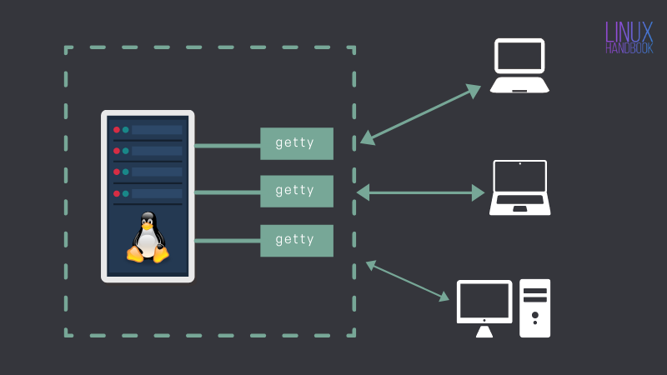
When you try to connect to a Linux system either directly (if you have a server installed on a system locally) or via SSH (if you have the server on a remote location), getty prompts (through login program) you to enter your username and when the user name is entered, it prompts for the password.
Your entries are verified against the information stored in /etc/passwd file. The entries in the /etc/passwd file has some information like username, userid, home directory and the first program that should be started after login succeeds.
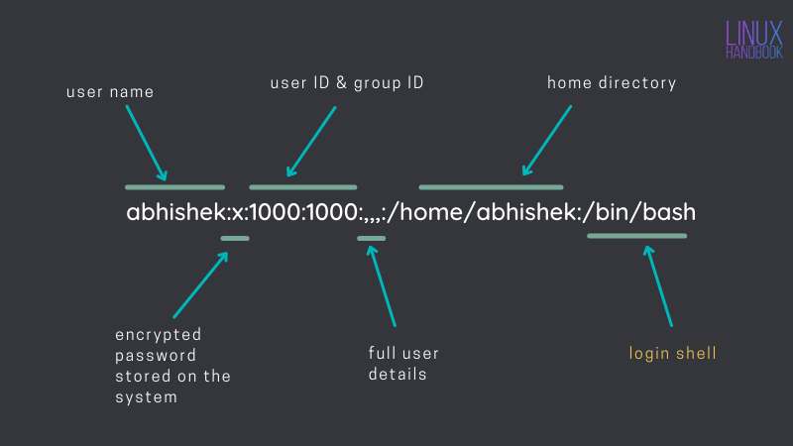
As you can see in the picture above, the first program to start when the user abhishek logs in. For standard users in Linux, it is the login shell.
There could be other values in the field as well. For example, sshd is a system user, not a real user and it can not log in to the system interactively like a regular user like abhishek.
sshd:x:110:65534::/run/sshd:/usr/sbin/nologin
If there is no entry in the column of the first program/log in shell, it is defaulted to /bin/sh, i.e. the standard shell.
I hope it was not too much information.

Login shell vs non-login shell
Alright, so you logged into a system and know that it's a login shell. But what does it mean? Are there other shells as well? Where are they?
In Linux, when you run a shell script, it runs in its own shell (a non-interactive shell). You can start a new shell from your current shell (an interactive shell).
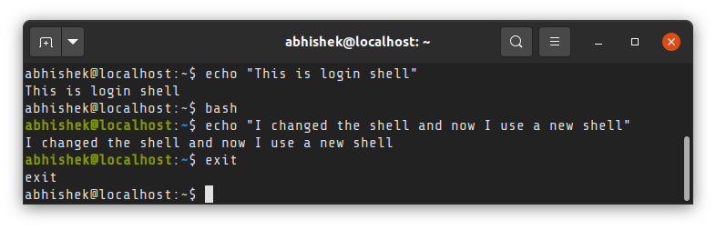
In technical terms, these are subshell but more on this topic later. Let's focus on login shell for now.

Profile and RC files for the shell
The login shell reads environment variable and other configuration from /etc/profile and a profile file in the home directory. This allows you to have tab completion, colored output and sets other stuff such as umask etc.
You probably know that there are more than one shell available for Linux systems. Most Linux distributions use bash shell by default but you may install a different shell like zsh or Fish shell.
If your login shell is bash, it reads from /etc/profile and ~/.bash_profile file. If your login shell is zsh, it reads from /etc/zprofile and ~/.zprofile.
The files in /etc directory sets the respective shell configuration for all the users on the system. This is normally set up by the system administrator.
The files in the home directory of the user are user-specific, obviously. This allows users to create alias for frequently used commands or use a custom PATH variable for a program.
The non-login shells originates from the login shell and hence it gets all the environment set by the login shell via the profile files. In addition to that, non-login, interactive shell can define their own environment variables through rc (resource configuration) files in /etc or home directory.
For bash shell, it is usually, /etc/bash.bashrc and ~/.bash_rc files while for zsh shell, it is /etc/zshrc and ~/.zshrc.
Let me show the difference with a practical example.
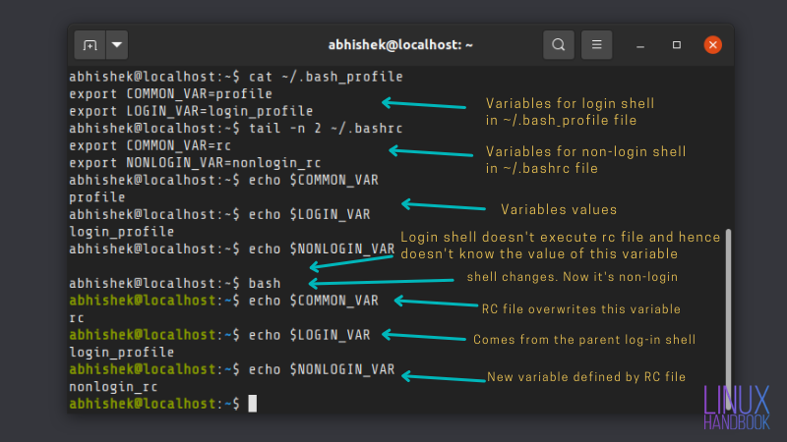
Notice how the shell prompt changes to green-ish color? It's because it reads /etc/bash.bashrc file and Ubuntu has put additional parameters in this file. Colored prompt is one of them.
To summarize:
- The profile files are for interactive login shells. The rc files are for interactive non-login shells.
- Files in /etc directory are executed first and then the files in the home directory.
- The non-login, interactive shells benefit from both profile and rc files.

How to know if you are in a login shell?
That's very simple actually, at least for the bash shell. For login shell, the name of the shell executable starts with -. For non-login shell, it's just the name of the shell.
You know how to check the shell, right? You check the value of argument 0.
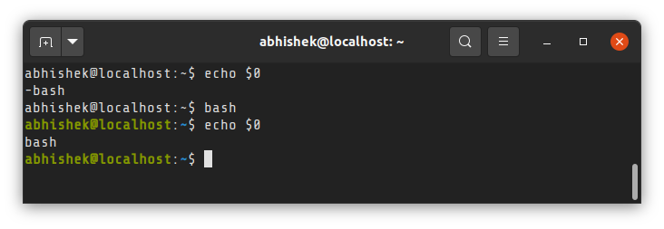
On desktop Linux, you don't use login shell. Your login is managed by a display manager. This is why when you open a terminal in Linux desktop, you'll see that even the first shell running in the terminal is not login shell.
I have tried to make things clear about login shell here. However, if you never wondered about these things, it may leave some unanswered questions. Feel free to ask it in the comment section and I'll try to answer them.
If you are an expert user reading this and find something technically incorrect or some important point missing, please let me know in the comments

